 | FPT – ACADEMY INTERNATIONAL  CENTE NAME: FPT – APTECH 02  590 CMT8, DIS 03, HCM City | 

ONLINE POST OFFICE
MANAGEMENT SYSTEM

Approved By | Mr. TRUONG MAC CUONG  Mr. NGUYEN QUAN THANH
Batch No | F2-2007-0912-Y2
Group No | 04
Students |  | Full Name. | Roll No.
 | 1. | LE TAN DAT | VN.033/200805/0090
 | 2. | QUAN BUU MINH | VN.033/200807/0150
 | 3. | VU MINH TUAN | VN.033/200809/0283
 | 4. | NGUYEN TAN  CAT TUONG | VN.033/200808/0170
MAY 2010

REVIEW 02

Table of Contents
2.1. Use Case Diagram. 4
2.2. Use Case Description. 6
2.3. Sequence Diagram. 16
2.4. Entity Relationship Diagram (ERD). 19
2.5. Entity Description. 20
2.6. Table Design. 24
2.7. Table Relationship Diagram. 30

Use Case Diagram.

Use Case for Customer
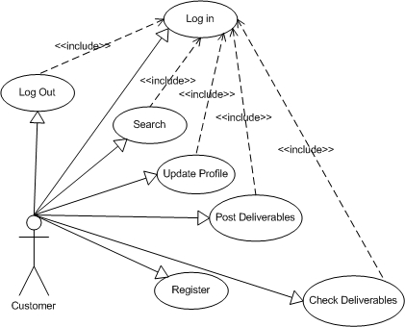

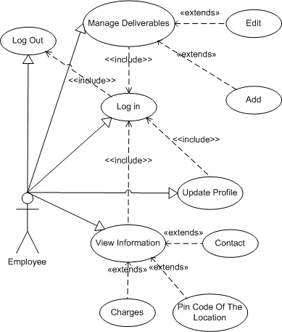
Use Case for Employee

Use Case for Admin
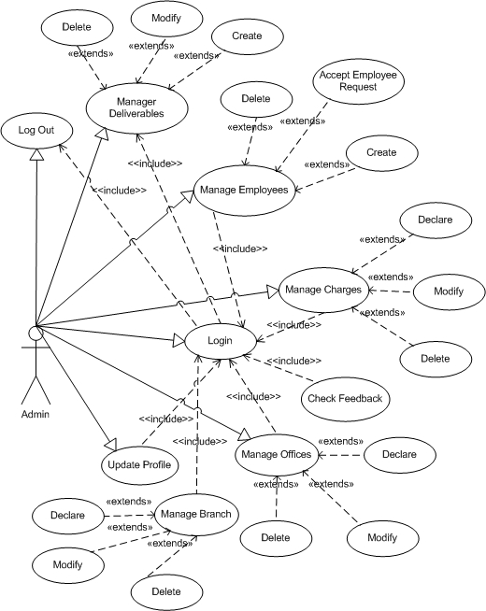

Use Case Description.

Customer
Usecase | Register
Short Description | Registration
Pre-Conditions | N/A
Post-Conditions | Success : new customer will be created and stored in database
Main flow | _ Customers must register the required information:  First Name  Last Name  Email (as a username for login to website)  Password  Birthday  Sex  Address  Phone  _ After providing the information, click the register button.  _ System will check the customer information provided.  _ System will store customer information in the database.
Alternative flow(s) | _ If the customer reset button, the system will automatically cancel the information logged.  _ If customers enter invalid, the system error.  _ Errors in entering registration information:  . Name and address not be less than 5 characters.  . Invalid email.  Invalid password  Invalid phone  . Any fields are blank.  _ System will automatically enter on customer registration.  _ After successful registration and posting, the system will inform customers.

Usecase | Posting Deliverables
Short Description | Customers must give details of their deliverables
Pre-Conditions | Customer must log in using his/her email and password
Post-Conditions | Success : deliverables will be posted to offices and stored in database
Main flow | _ Customers must login using their email(or PIN number), password  _ Then, customer can post their package. Their package must include the following information :  Type of package (email, form, parcel, or money order…)  Weight  Distance  _ Type of service chosen  _ System will store the details of deliverable.
Alternative flow(s) | _ Errors in entering details of deliverable :  Above or below the allowed weight  Above or below the allowed distance

Usecase |  | Login
Short Description |  | Customer can login to check delivering status
Pre-Conditions |  | Customer must have his/her email and password
Post-Conditions |  | N/A
Main flow |  | _ Customers must enter their email, or PIN number(if they forget their email) and password to login to the website  after the login, they can choose to :  can check the status of their deliverable through the delivery number  update their profiles  posting another package  _ System will provide the corresponding option
Alternative flow(s) |  | _ If the email or password is incorrect, the system error  _ If customers cannot remember their email (or PIN number), the system will inform a way to get back their email(or PIN number)
Usecase | Logout
Short Description | Customers can log out their current account
Pre-Conditions | Customer must log in using his/her email and password
Post-Conditions | N/A
Main flow | _ Customers log out their current account by pressing the logout button.  _ System will return to the homepage.
Alternative flow(s)

Usecase | Update Profile
Short Description | Customers can update their profile
Pre-Conditions | Customer must log in using his/her email and password
Post-Conditions | Success : new information will be stored in database
Main flow | _ After logging in, customers can update their account, like:  Change their email  Change their password  Change their name  Change their gender  Change their address  Change their phone  Change their birth date  _ Customers click the update button  _ Then, system will check the customer information  _ If the information is valid, system will update the new customer profile and inform the customers.  _The new details will be updated in database
Alternative flow(s) | If customers provide invalid information, system will inform errors
Usecase |  | Search
Short Description |  | Customers can search for their deliverables
Pre-Conditions |  | Customer must log in using his/her email and password
Post-Conditions |  | N/A
Main flow |  | _ Customers can choose the advanced search option that system provide  _ Customers must provide their Delivery Number to search for their deliverables  _ System provide the details of the corresponding deliverable
Alternative flow(s) |  | _ System will inform error deliverables not found if the delivery number is not matching.

Usecase | Checking Deliverables
Short Description | Customers can check their delivering status
Pre-Conditions | Customer must log in using his/her email and password
Post-Conditions | N/A
Main flow | _ Customer must provide their email(or PIN number) and password to login  _ After login, customer can check the status of delivering through the delivery number  _ System will provide the status of their corresponding deliverables
Alternative flow(s) | _If customer provide wrong email(or PIN number) or password, system will inform error  _If customer cannot remember their email(or PIN number) or password, system will inform a way for customer to get back their email(PIN number) or password

Employee
Usecase | Login
Short Description | Employee must provide their username and password to login
Pre-Conditions | N/A
Post-Conditions | Success : employees will have their respective rights
Main flow | _ First employee will receive username and password created by the admin  _ Then, they must enter their appropriate username and password to login  _ Employee click on Login button  _ System will return a page for employee  _ System will give them the appropriate authorities
Alternative flow(s) | _ If employee enter wrong username or password, system will inform error.

Usecase | Logout
Short Description | Employee can log out of their account
Pre-Conditions | Employee must log in using his/her email and password
Post-Conditions | N/A
Main flow | _ Employee can log out of their account by pressing the logout button  _ System will return them to the homepage
Alternative flow(s)

Usecase | Manage deliverables
Short Description | Employee can manage the details of deliverables after logging in
Pre-Conditions | Employee must log in using his/her email and password
Post-Conditions | Success : new deliverable details will be added
Main flow | After the login, employee can choose the following options:  View the details of the current deliverables  Add the details of the current deliverable  Edit the details of the current deliverable  System will provide a corresponding page for employee  System will check the new information entered  If the new details are valid, system will inform the employee and store the new details in database
Alternative flow(s) | System will inform error if the details entered are invalid

Usecase | Update Profile
Short Description | Employees can update their profiles
Pre-Conditions | Employee must log in using his/her email and password
Post-Conditions | N/A
Main flow | After login, employee can update their profile :  Their profile can be changed only after the admin accept their change request  New profile will be updated in database
  Employee Email
  Employee Password
  Employee First Name
  Employee Last Name
  Employee Birthday
  Employee Sex
  Employee Address
  Employee Phone
  Employee Image
Alternative flow(s) | System will inform error if the details entered are invalid
Usecase |  | View Information
Short Description |  | Employee can view the information
Pre-Conditions |  | Employee must log in using his/her email and password
Post-Conditions |  | N/A
Main flow |  | _After login, employee can choose to view the details of  Deliverables  Charges  Contacts  PIN code based on location  _System will provide the corresponding information
Alternative flow(s) |  | _System will inform error if employee choose to view the details of the other employees

ADMIN
Usecase | Login
Short Description | Admin must provide their username and password to log in
Pre-Conditions | N/A
Post-Conditions | Success : admin will be provided administrative rights
Main flow | Admin click on login button  System will return a page for the admin  Admin will be provided the appropriate authorities.
Alternative flow(s) | System will inform error if admin provide wrong username or password

Usecase | Logout
Short Description | Admin can log out of his/her account
Pre-Conditions | Admin must log in using his/her email and password
Post-Conditions | N/A
Main flow | admin click on the logout button ,system will return to homepage
Alternative flow(s)
Usecase |  | Manage Employees
Short Description |  | Admin has the rights to manage employees
Pre-Conditions |  | Admin must log in using his/her email and password
Post-Conditions |  | Success : new employee information will be created and stored in database
Main flow |  | _Admin can choose to :  Create a new username and password for employees  Deleting employees  Accepting update profile request from employees  _System will provide a corresponding page for the admin  _System will inform each employee their respective username and password  _System will update new details of employee  _New details of employee will be stored in database
Alternative flow(s) |  | System will inform error if admin enter invalid username or password.

Usecase | Manage Charges
Short Description | Admin can insert, delete, modify charges
Pre-Conditions | Admin must log in using his/her email and password
Post-Conditions | Success : new charges will be created and stored in database
Main flow | _Admin can have the following options :  Declare new charges  Modify charges  Delete charges  _ System will provide the corresponding page for admin  _ System will check for the new information  _ New details will be stored in database
Alternative flow(s) | System will inform error if admin enter invalid charges

Usecase | Manage Branch
Short Description | Admin has the option to manage Branches
Pre-Conditions | Admin must log in using his/her email and password
Post-Conditions | Success : New branches will be created and stored in database
Main flow | _ Admin can choose to :  Declare new Branches  Modify Branches  Delete Branches  _ System will provide a respective page for admin  _ System will check for the new information  _ New details will be stored in database
Alternative flow(s) | _System will inform error if admin enters invalid details of Branches

Usecase | Manage Offices
Short Description | Admin has the option to manage offices
Pre-Conditions | Admin must log in using his/her email and password
Post-Conditions | Success : New offices will be created and stored in database
Main flow | _ Admin can choose to :  Declare new offices  Modify offices  Delete offices  _System will provide a respective page for admin  _System will check for the new information  _New details will be stored in database
Alternative flow(s) | _System will inform error if admin enters invalid details of offices

Usecase | Update Profile
Short Description | Admin can update his/her profile
Pre-Conditions | Admin must log in using his/her email and password
Post-Conditions | Success : Details will be saved in database
Main flow | _Admin can choose to update his/her profile :  Email  Password  First Name  Last Name  Birthday  Sex  Address  Phone  _System will provide the corresponding page  _System will check for the new information  _The new details will be updated in database
Alternative flow(s) | _System will inform error if admin enter invalid information

Usecase | Check Feedback
Short Description | Admin can check feedbacks from customers
Pre-Conditions | Admin must log in using his/her email and password
Post-Conditions | N/A
Main flow | _Admin can choose to check feedback from customers  _System will provide the corresponding page displaying customers’ feedbacks
Alternative flow(s)

Sequence Diagram.

Customer
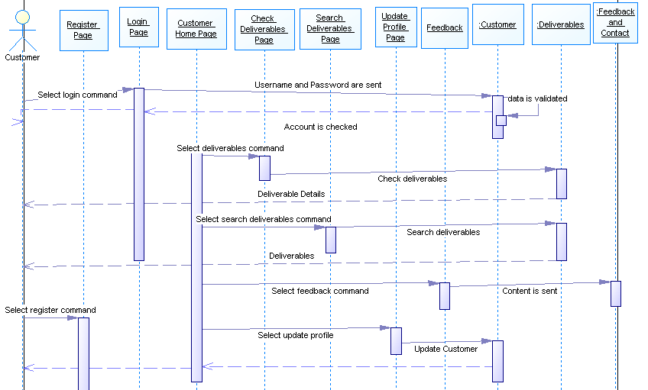

Employee
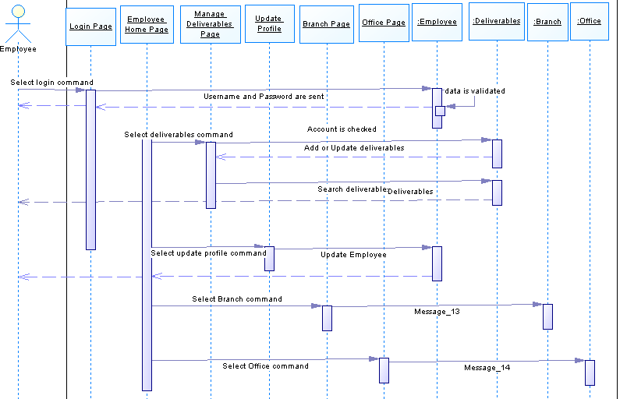

Admin
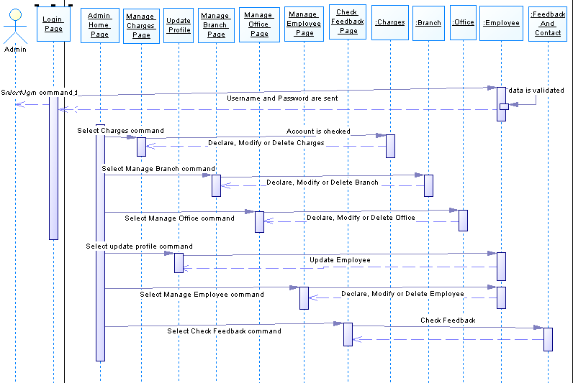

Entity Relationship Diagram (ERD).

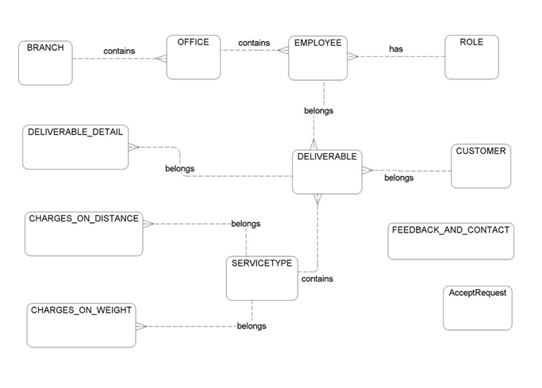

Entity Description.

BRANCH
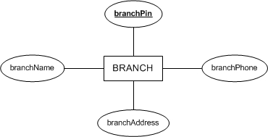

OFFICE
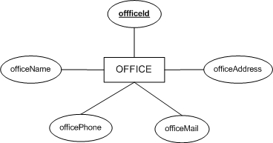

ROLES
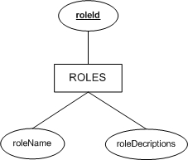

EMPLOYEE
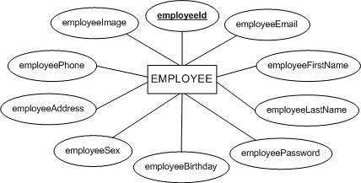

CUSTOMER
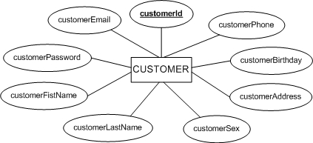

AcceptRequest
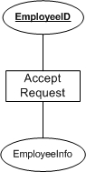

DELIVERABLE
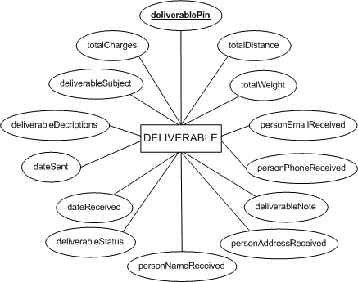

SERVICETYPE
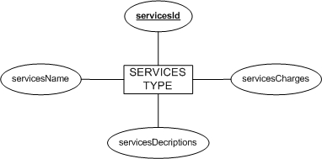

CHARGES_ON_WEIGHT
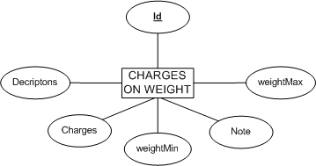

CHARGES_ON_DISTANCE
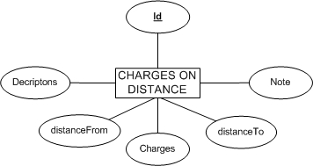

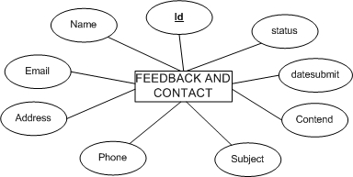
FEEDBACK_AND_CONTACT

Table Design.

BRANCH: describes details of branches including : PIN, Name,…
No | Column Name | Data Type | Size | Check | Description
1 | branchPin | varchar | 10 | Not Null | PIN code based on location
2 | branchName | varchar | 50 | Not Null | Name of branch
3 | branchAddress | varchar | 250 | Null | Address of branch
4 | branchPhone | varchar | 20 | Null | Phone of branch

OFFICE: describes details of offices including : Name, Address, Phone, Mail, PIN
No | Column Name | Data Type | Size | Check | Description
1 | offficeId | varchar | 10 | Not Null | Office ID
2 | officeName | varchar | 50 | Not Null | Name of office
3 | officeAddress | varchar | 250 | Not Null | Address of office
4 | officePhone | varchar | 20 | Not Null | Phone of office
5 | officeMail | varchar | 50 | Not Null | Mail address of office
6 | branchPin | varchar | 10 | Not Null | PIN code of branch based on location

ROLE: refers to the role of the user logged in
No | Column Name | Data Type | Size | Check | Description
1 |  roleId | varchar | 20 | Not Null | Role ID
2 | roleName | varchar | 50 | Not Null | Name of user after login
3 | roleDecriptions | varchar | 250 | Null | Details of user after login

EMPLOYEE: describes details of employees including :Email, Password, First Name, LastName, Birthday, Sex, Address, Phone, Image, Office ID, Role ID
No | Column Name | Data Type | Size | Check | Description
1 |  employeeId | varchar | 10 | Not Null | Employee ID
2 | employeeEmail | varchar | 50 | Not Null | Email of employee
3 | employeePassword | varchar | 50 | Not Null | Password of employee
4 | employeeFirstName | varchar | 50 | Not Null | First name of employee
5 | employeeLastName | varchar | 50 | Not Null | Last name of employee
6 | employeeBirthday | datetime |  | Not Null | Birth date of employee
7 | employeeSex | bit |  | Not Null | Gender of employee
8 | employeeAddress | varchar | 250 | Not Null | Address of employee
9 | employeePhone | varchar | 20 | Null | Phone of employee
10 | employeeImage | varchar | 50 | Null | Display picture of employee
11 | offficeId | varchar | 10 | Not Null | Office ID
12 | roleId | varchar | 10 | Not Null | Role ID

CUSTOMER: describes details of customerss including :Email, Password, First Name, LastName, Birthday, Sex, Address, Phone
No | Column Name | Data Type | Size | Check | Description
1 |  customerId | varchar | 10 | Not Null | Customer ID
2 | customerEmail | varchar | 50 | Not Null | Email of customer
3 | customerPassword | varchar | 50 | Not Null | Password of customer
4 | customerFistName | varchar | 50 | Not Null | First name of customer
5 | customerLastName | varchar | 50 | Not Null | Last name of customer
6 | customerBirthday | datetime |  | Null | Birth date of customer
7 | customerSex | bit |  | Null | Gender of customer
8 | customerAddress | varchar | 250 | Not Null | Address of customer
9 | customerPhone | varchar | 20 | Null | Phone of customer

SERVICESTYPE: describes details of services like : ID, Name, Desciption, Charges
No | Column Name | Data Type | Size | Check | Description
1 |  servicesId | varchar | 10 | Not Null | Service ID
2 | servicesName | varchar | 50 | Not Null | Name of service
3 | servicesDecriptions | varchar | 250 | Null | Details of service
4 | servicesCharges | float |  | Not Null | Charges of service

DELIVERABLE: describes information of deliverables
No | Column Name | Data Type | Size | Check | Description
1 | deliverablePin | varchar | 10 | Not Null | PIN code of deliverable
2 | customerSent | varchar | 10 | Not Null | ID of customer who
3 | deliverableSubject | varchar | 50 | Not Null | Subject of deliverable
4 | deliverableDecriptions | varchar | 250 | Null | Details of deliverable
5 | dateSent | datetime |  | Not Null | Date of sending deliverable
6 | dateReceived | datetime |  | Null | Date of receive deliverable
7 | personNameReceive | varchar | 50 | Not Null | Name of person who receive the deliverable
8 | personAddressReceive | varchar | 250 | Not Null | Address of person who receive the deliverable
9 | personPhoneReceive | varchar | 20 | Null
10 | personEmailReceive | varchar | 50 | Null
11 | totalWeight | float |  | Not Null | Weight of deliverable
12 | totalDistance | float |  | Not Null | Distance of delivering
13 | totalCharges | float |  | Not Null | Total charges
14 | deliverableStatus | bit |  | Not Null | Status of deliverable
15 | deliverableNote | varchar | 250 | Null | Note
16 | servicesType | varchar | 10 | Not Null | Type of service
17 | employeeId | varchar | 10 | Not Null | Employee ID

DELIVERABLE_DETAIL: displays details of Deliverables including ID, PIN, Name, Weight, Descriptions, Note,…
No | Column Name | Data Type | Size | Check | Description
1 |  detailId | varchar | 10 | Not Null | Detail ID
2 | deliverablePin | varchar | 10 | Not Null | PIN code of deliverable
3 | deliverableName | varchar | 50 | Not Null | Name of deliverable
4 | deivrableWeight | float |  | Not Null | Total weight of deliverable
5 | Decriptions | varchar | 250 | Null | Details of deliverable
6 | Note | varchar | 250 | Null | Note

CHARGES_ON_WEIGHT displays details of charges on weight including Descriptions, Minimum Weight, Maximum Weigth, Charges, Note and Types of Services.
No | Column Name | Data Type | Size | Check | Description
1 |  Id | varchar | 10 | Not Null | ID of charge
2 | Decriptons | varchar | 250 | Not Null | Description of weight charge
3 | weightMin | float |  | Not Null | Minimum of weight
4 | weightMax | float |  | Not Null | Maximum of weight
5 | Charges | float |  | Not Null | Charge on weight
6 | Note | varchar | 10 | Null | Note
7 | servicesType | varchar | 10 | Not Null | Type of service preferred

CHARGES_ON_DISTANCE: displays details of charges on distance including Descriptions, Distance From, Distance To, Charges, Note and Types of Services.
No | Column Name | Data Type | Size | Check | Description
1 |  Id | varchar | 10 | Not Null | ID of charge
2 | Decriptons | varchar | 250 | Not Null | Description of distance charge
3 | distanceFrom | float |  | Null | Place of sending
4 | distanceTo | float |  | Null | Destination of receiving
5 | Charges | float |  |  | Charge on distance
6 | Note | varchar | 250 |  | Note
7 | servicesType | varchar | 10 |  | Type of service preferred

FEEDBACK_AND_CONTACT: displays the details of user’s feedback and contact including Name, Email, Address, Phone, Subject of feedback and Content of feedback .
No | Column Name | Data Type | Size | Check | Description
1 |  Id | varchar | 10 | Not Null | ID of person who sends feedback
2 | Name | varchar | 50 | Not Null | Name of person who sends feedback
3 | Email | varchar | 50 | Not Null | Email of person who sends feedback
4 | Address | varchar | 250 | Not Null | Address of person who sends feedback
5 | Phone | varchar | 20 | Null | Phone of person who sends feedback
6 | Subject | varchar | 50 | Not Null | Subject of feedback
7 | Content | varchar | 250 | Not Null | Content of feedback

COUNT_VISIT: displays the number of customers visited
No | Column Name | Data Type | Size | Check | Description
1 | count | int |  | Not Null | Count the number of users visting the webiste

AcceptRequest: displays the details of employees asking for request including : ID and Employee Information
No | Column Name | Data Type | Size | Check | Description
1 | ID | INT | 10 | Not Null
2 | EmployeeInfo | XML |  | Not Null | Information of Employee

Table Relationship Diagram.
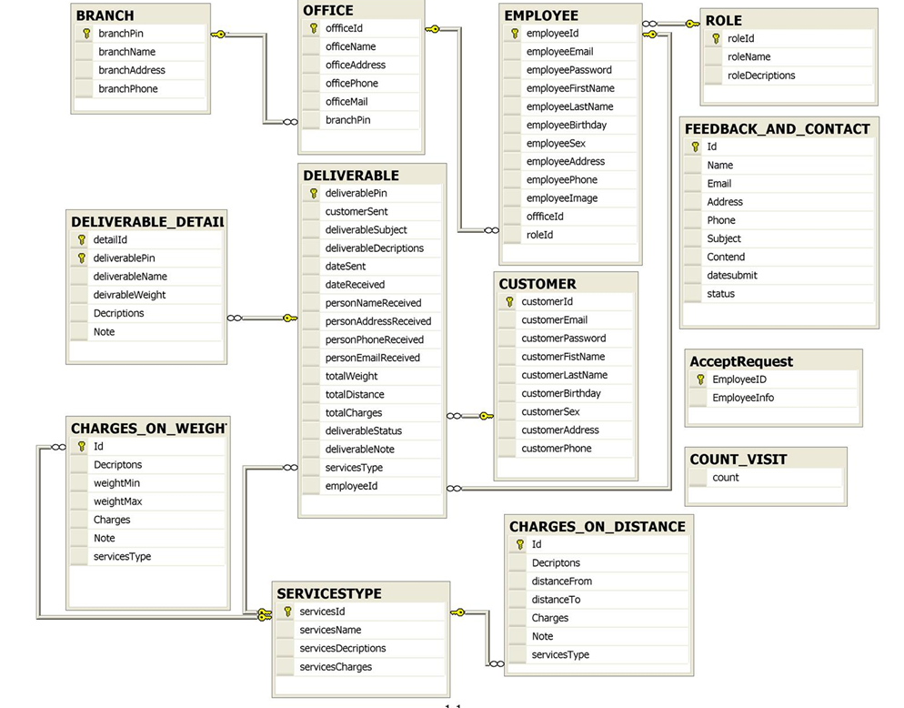

TASK SHEET REVIEW 02

Project  Ref. No. |  | Project Title | Activity Plan | Date of Preparation of Activity Plan
Sr. No | Task | Description | Planed Start Date | Actual Start Date | Actual Days | Team Mate Name | Status
1. | REVIEW-02 | Use Case Diagram. | 22-May-2010 | 22-May-2010 |  | All member of  team | OK
2 | REVIEW-02 | Use Case Description |  |  |  |  | OK
3 | REVIEW-02 | Sequence Diagram |  |  |  |  | OK
4 | REVIEW-02 | Entity Relationship Diagram |  |  |  |  | OK
5 | REVIEW-02 | Entity Description |  |  |  |  | OK
6 | REVIEW-02 | Table Design |  |  |  |  | OK
7 | REVIEW-02 | Table Relationship Diagram. |  |  |  |  | OK

